Lab 6

Overall System - Operation, Measurements, and Lab Equipment

Ezra Senanu

Kyle June

June 18

ECEN 299

Pictures

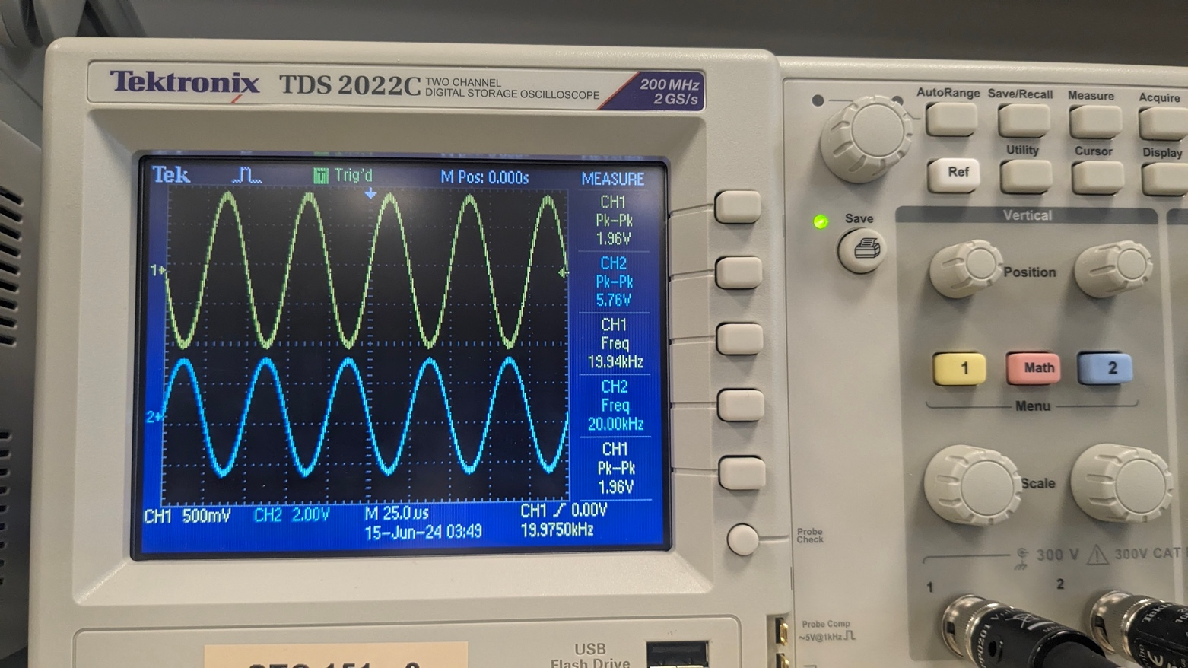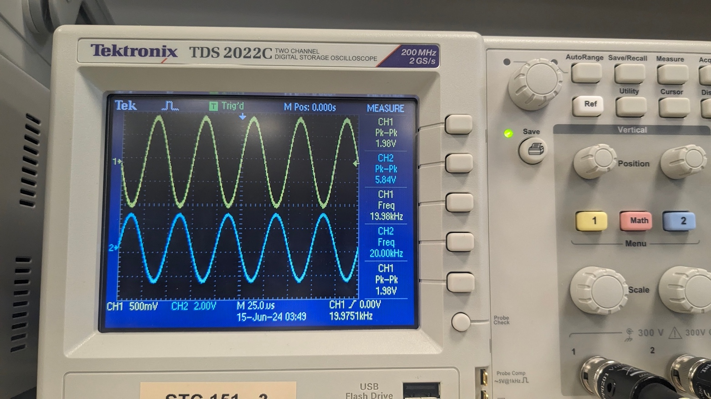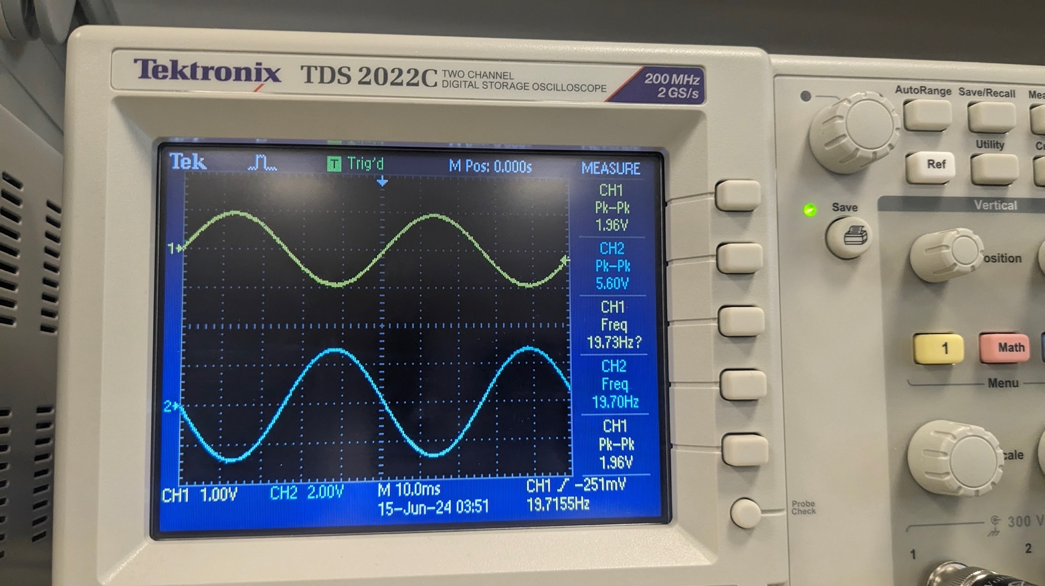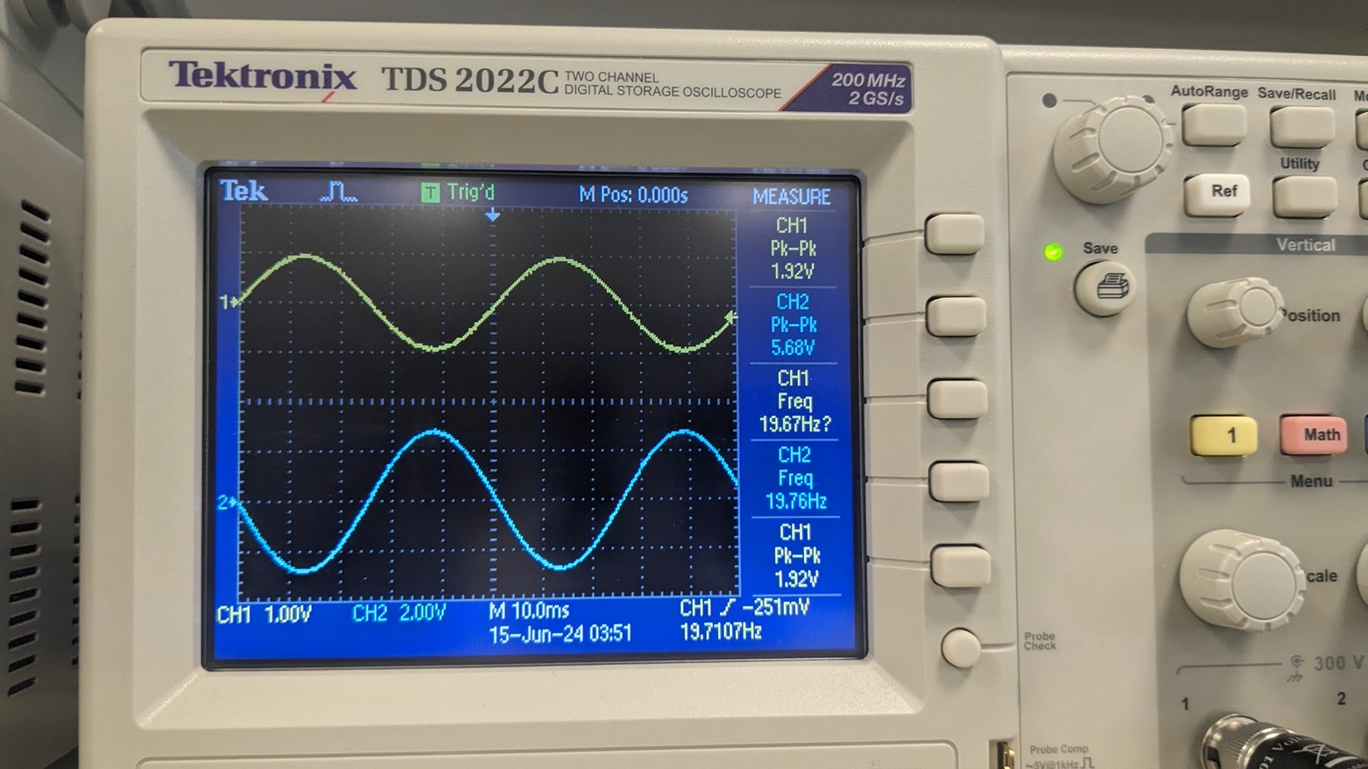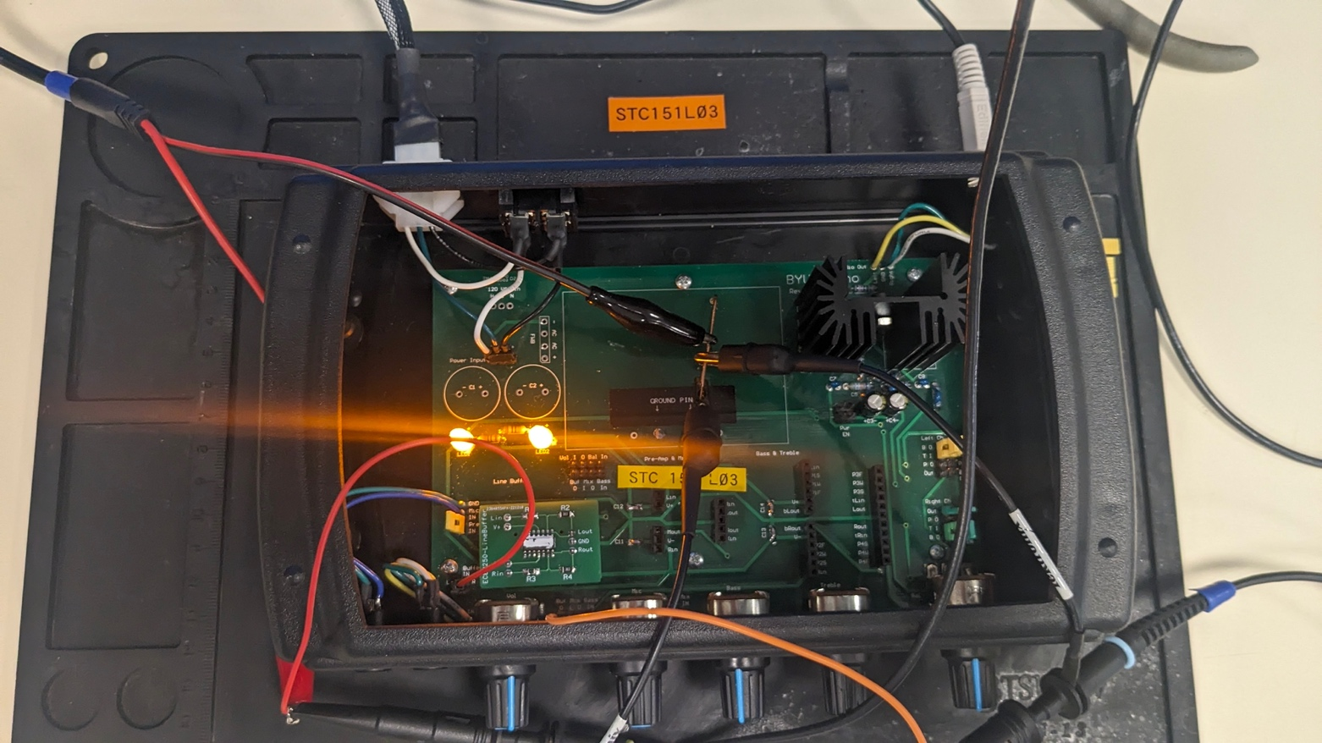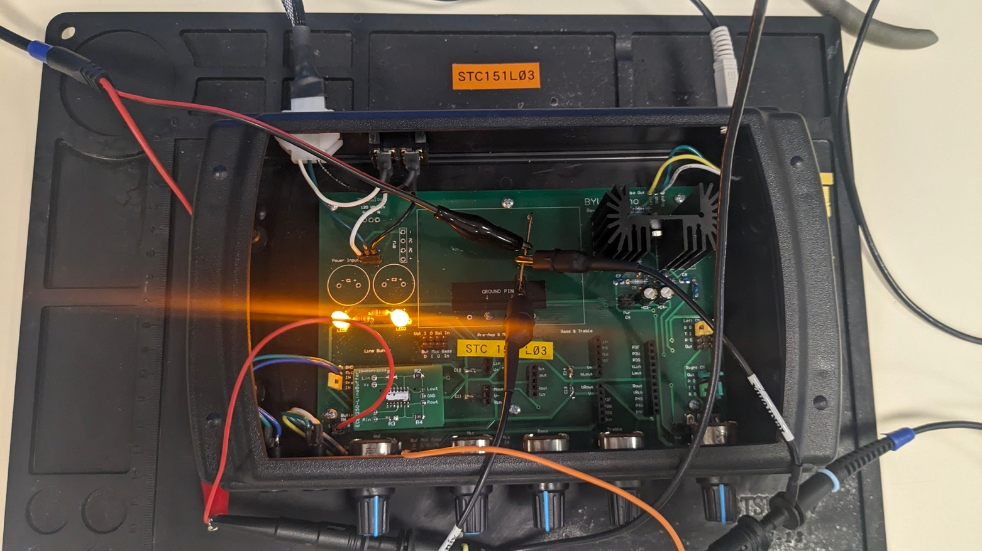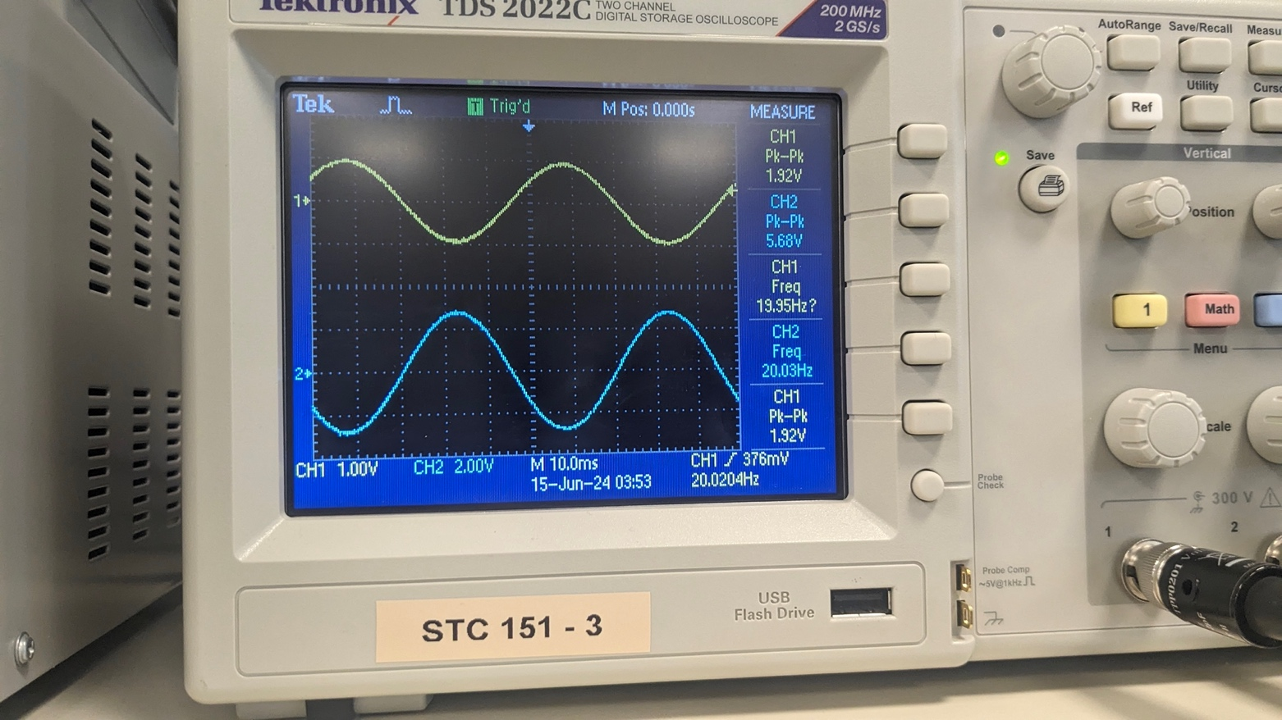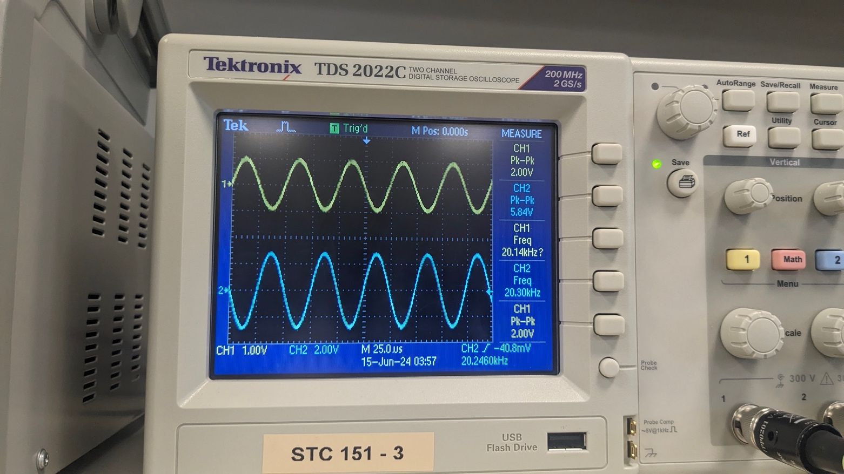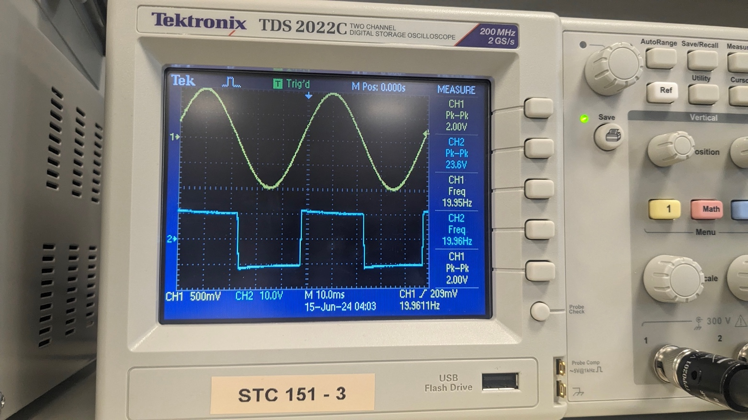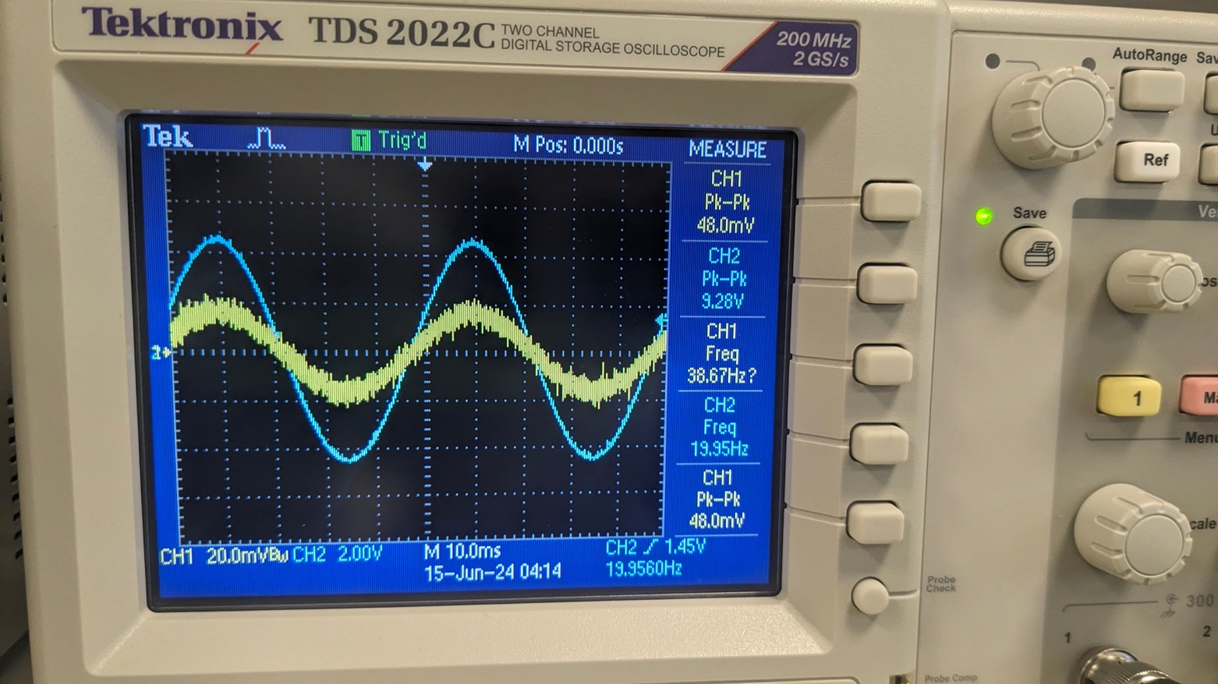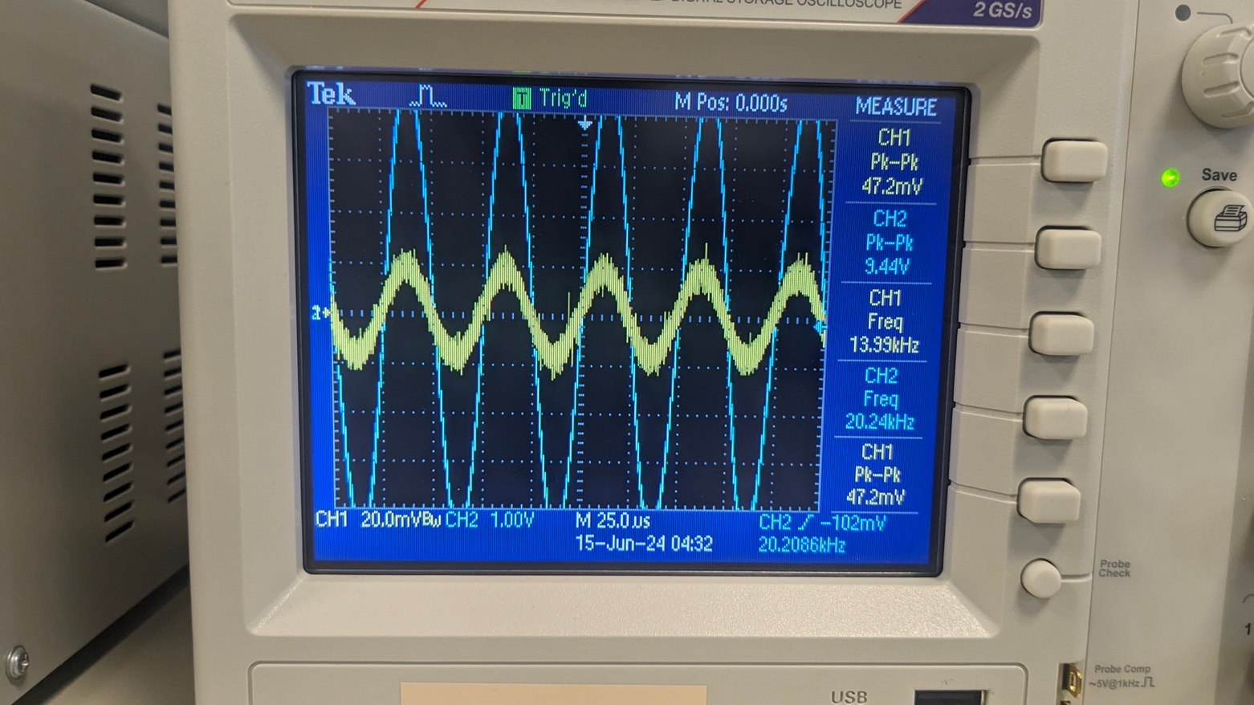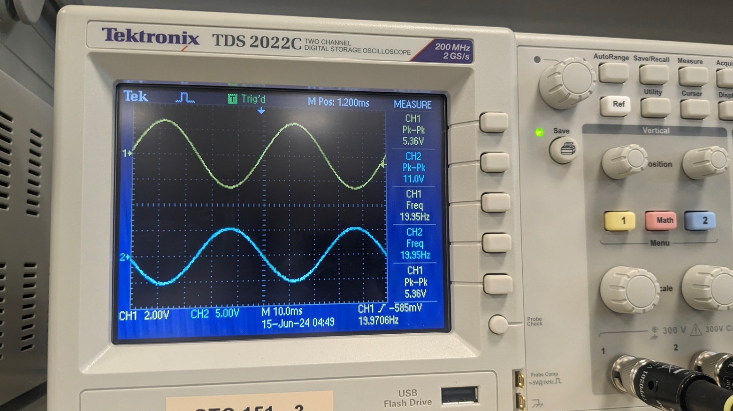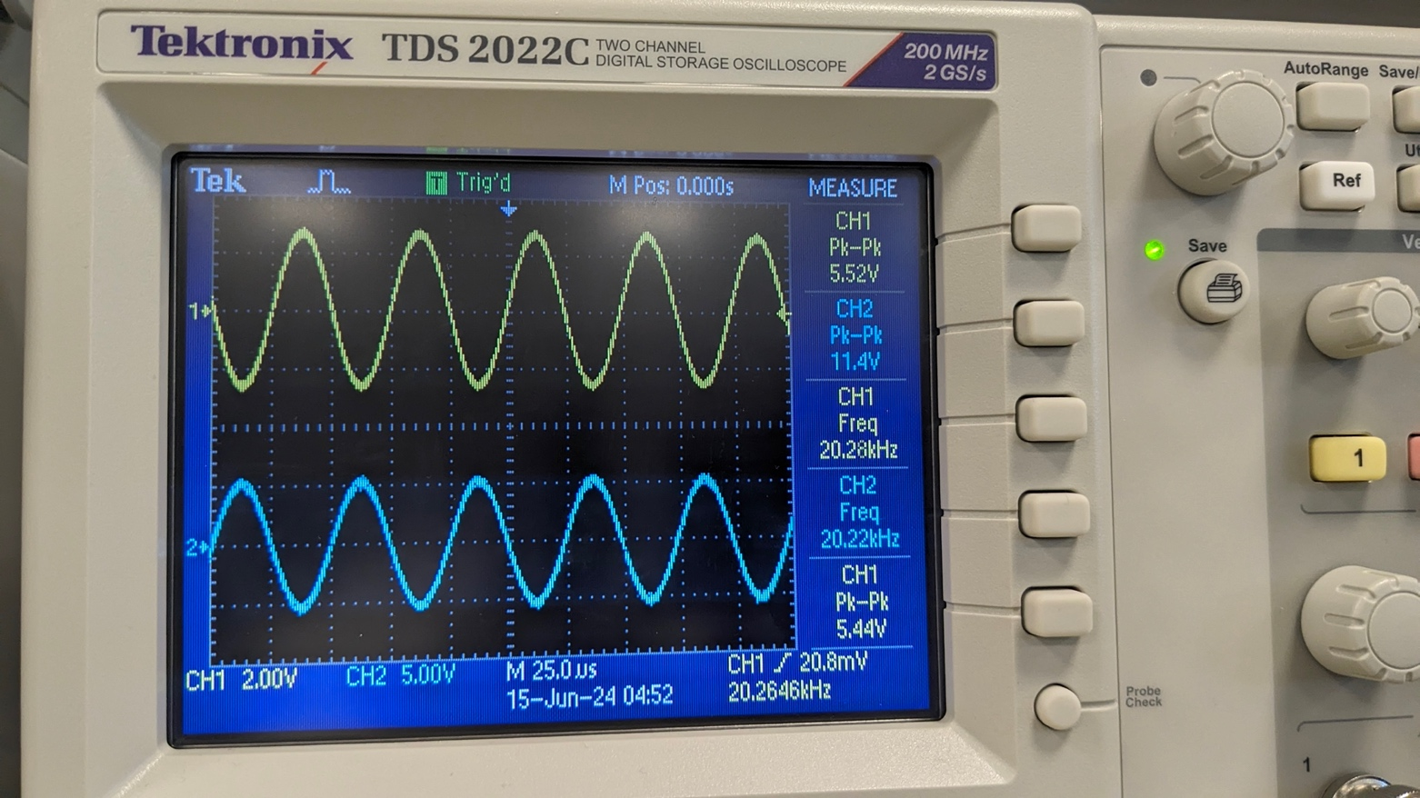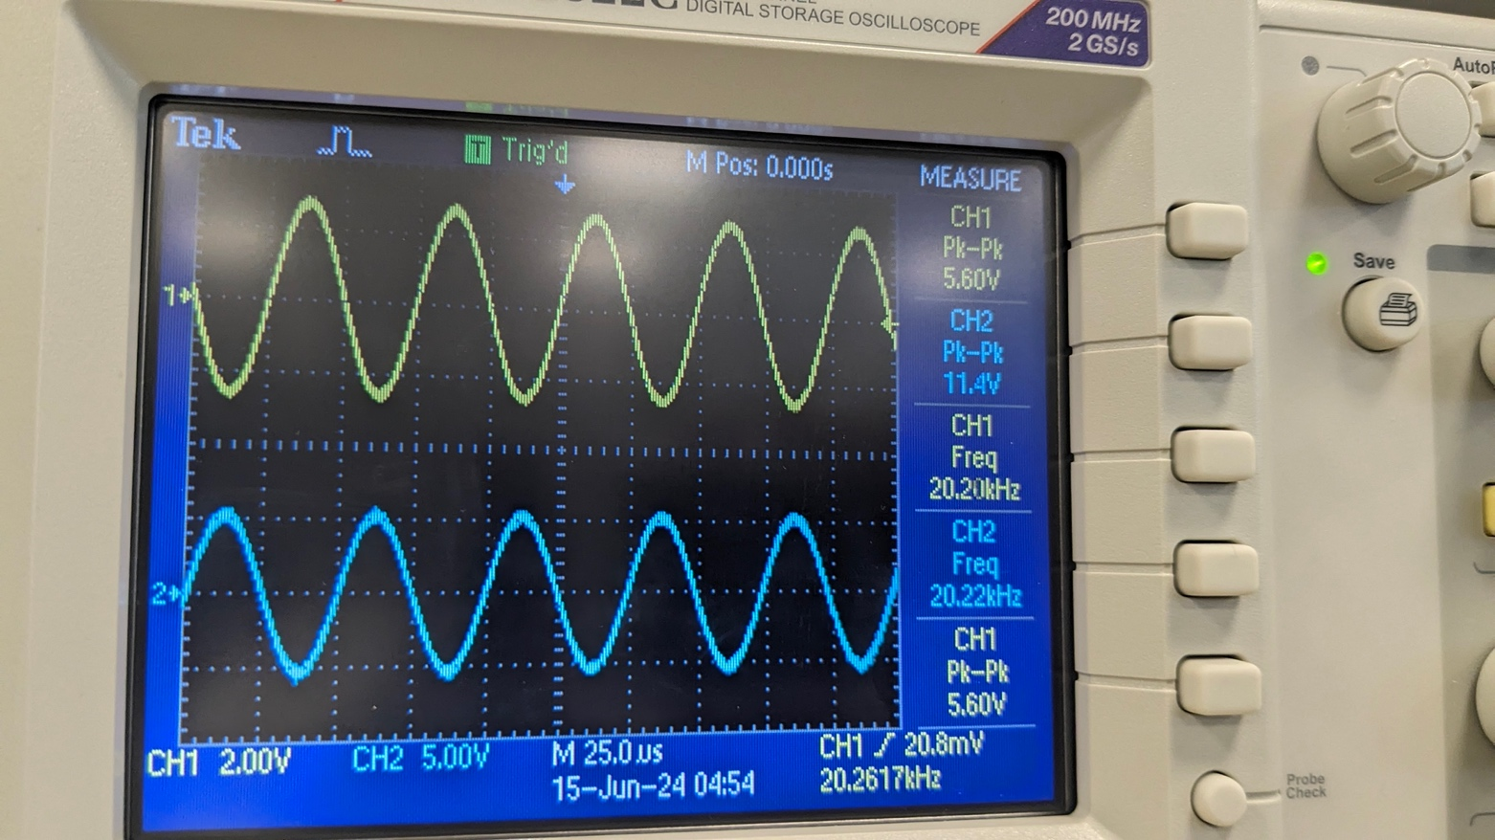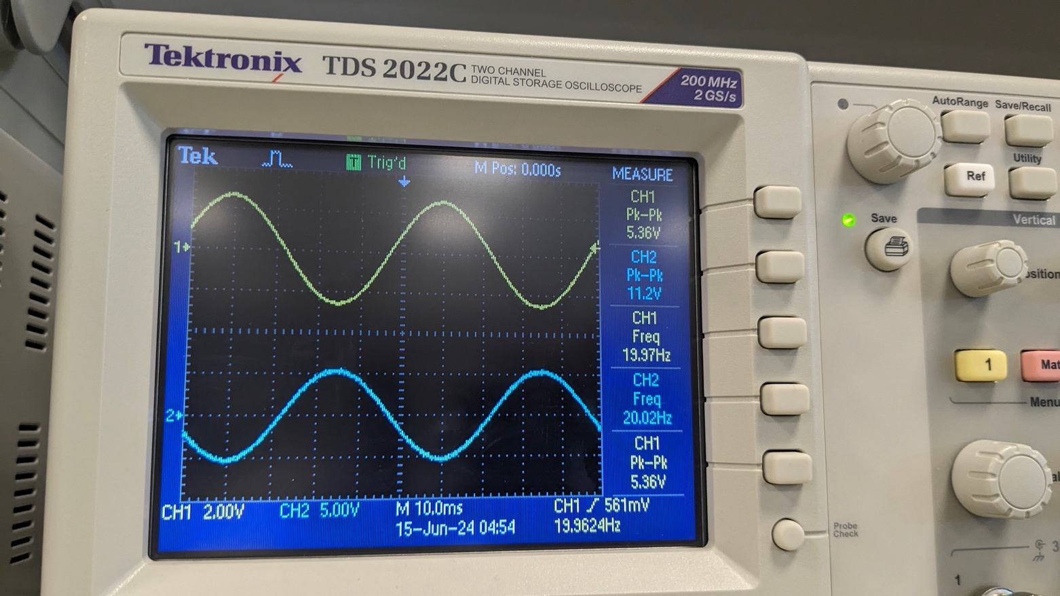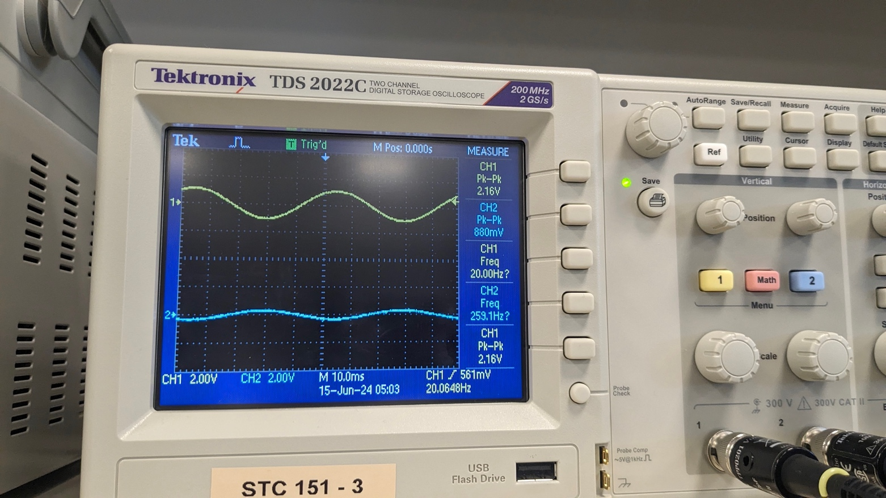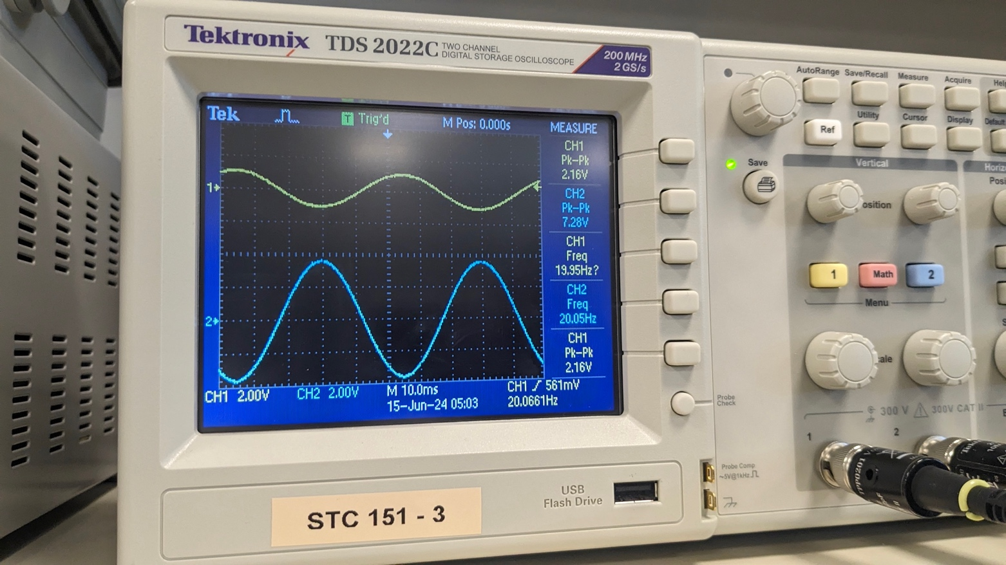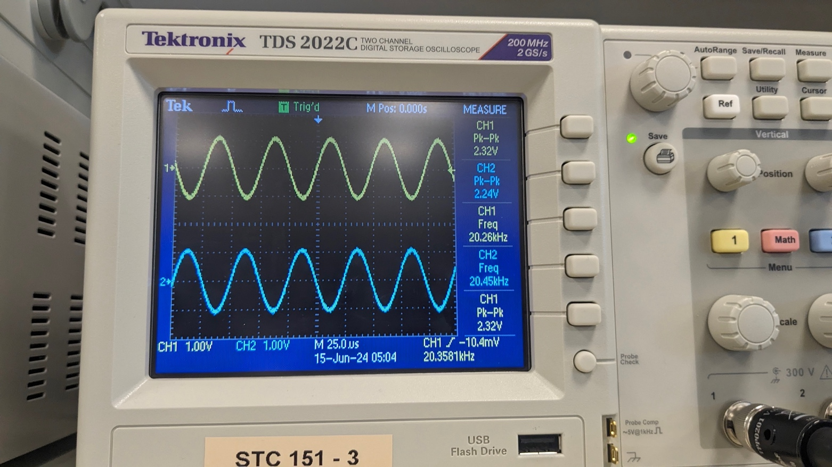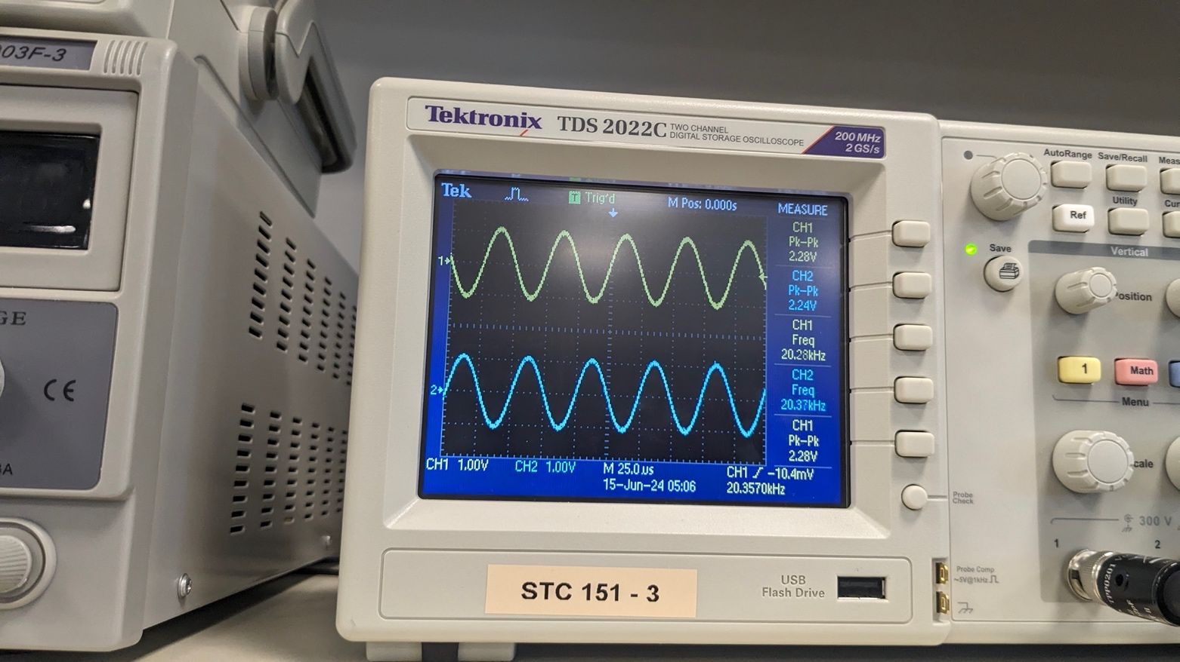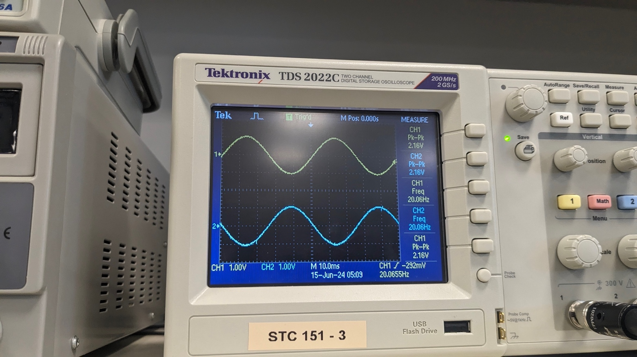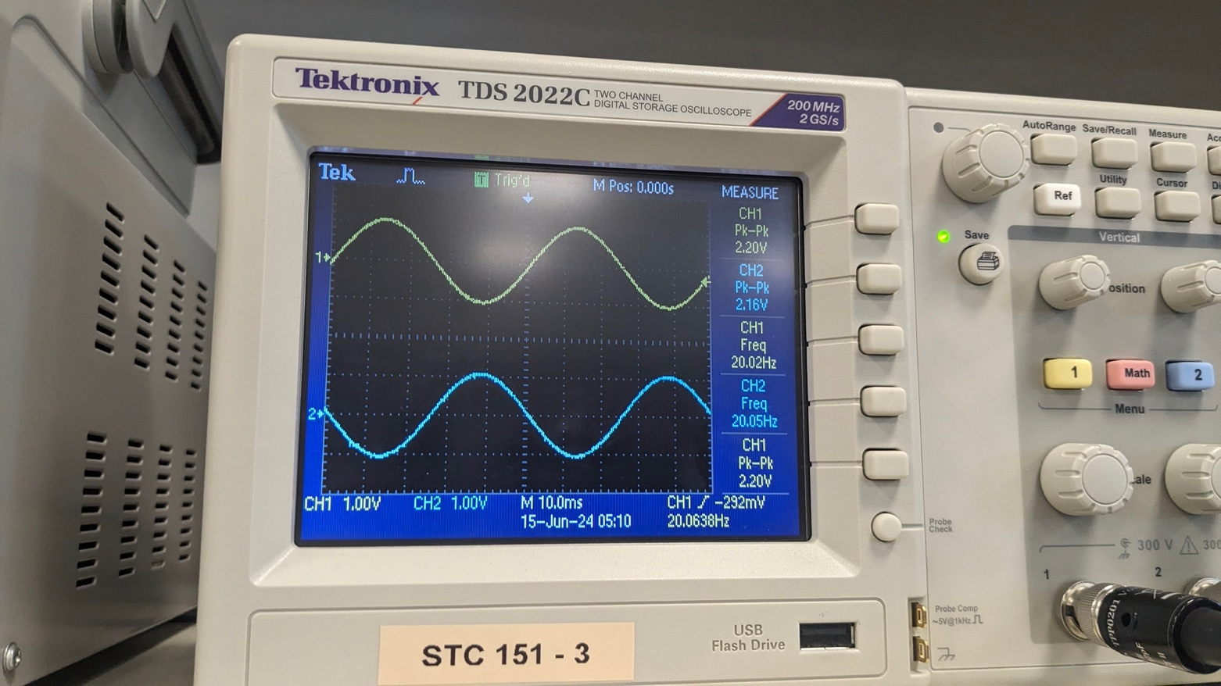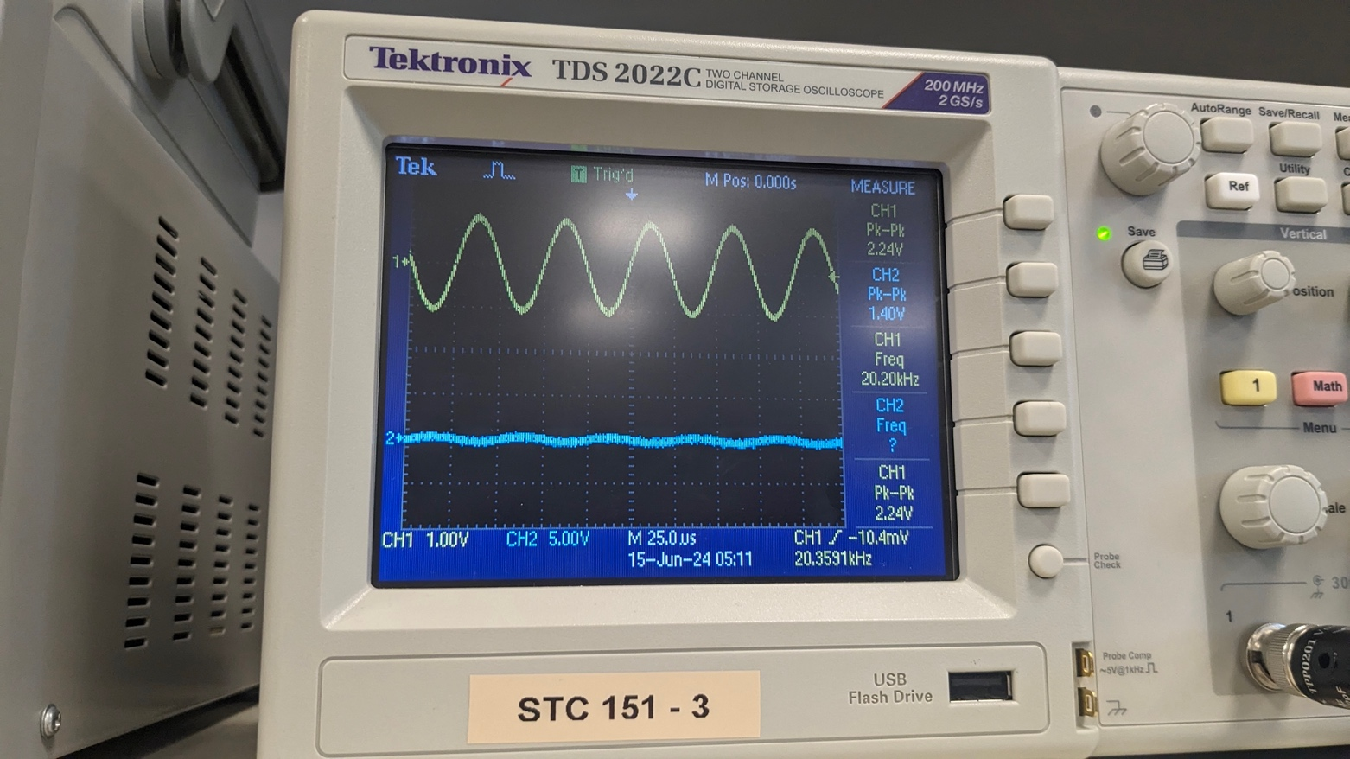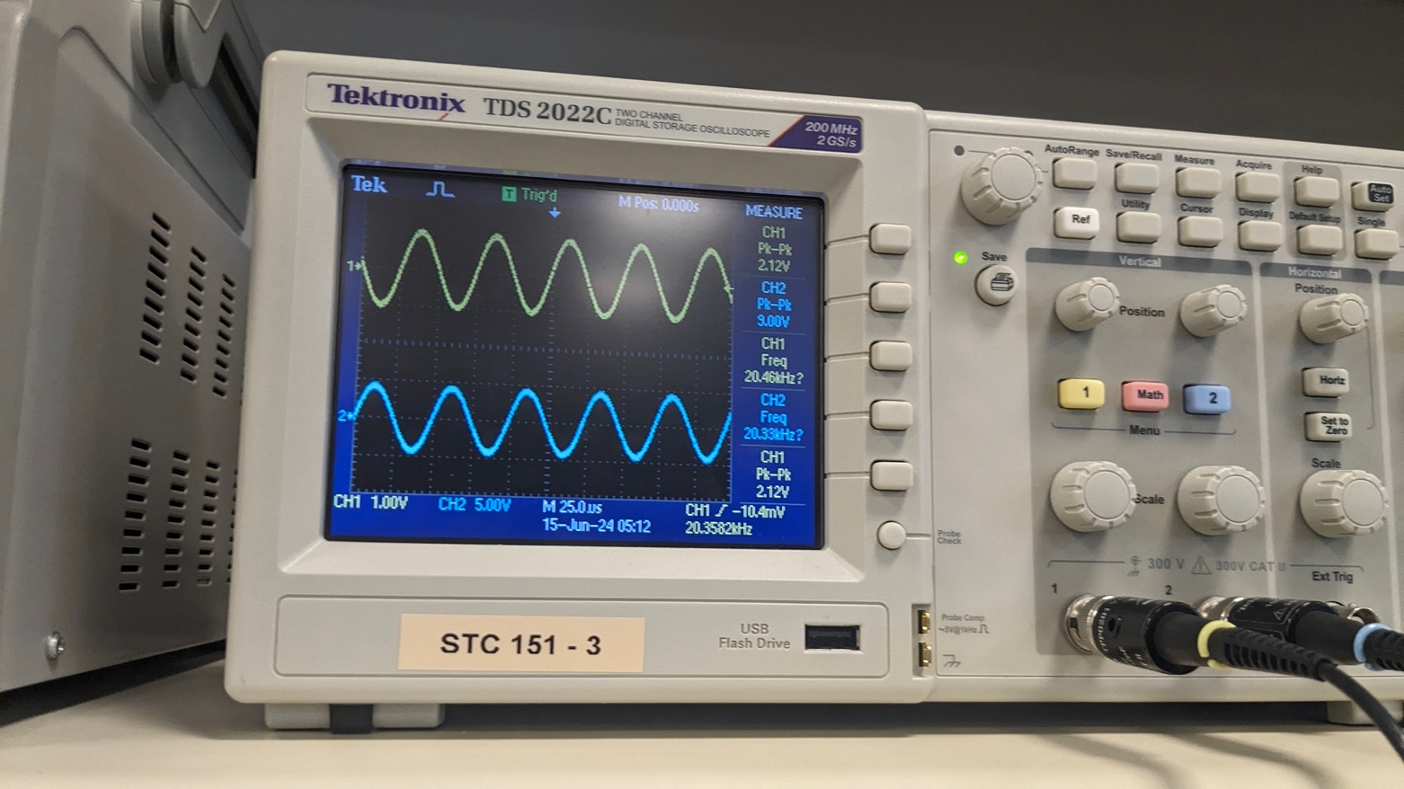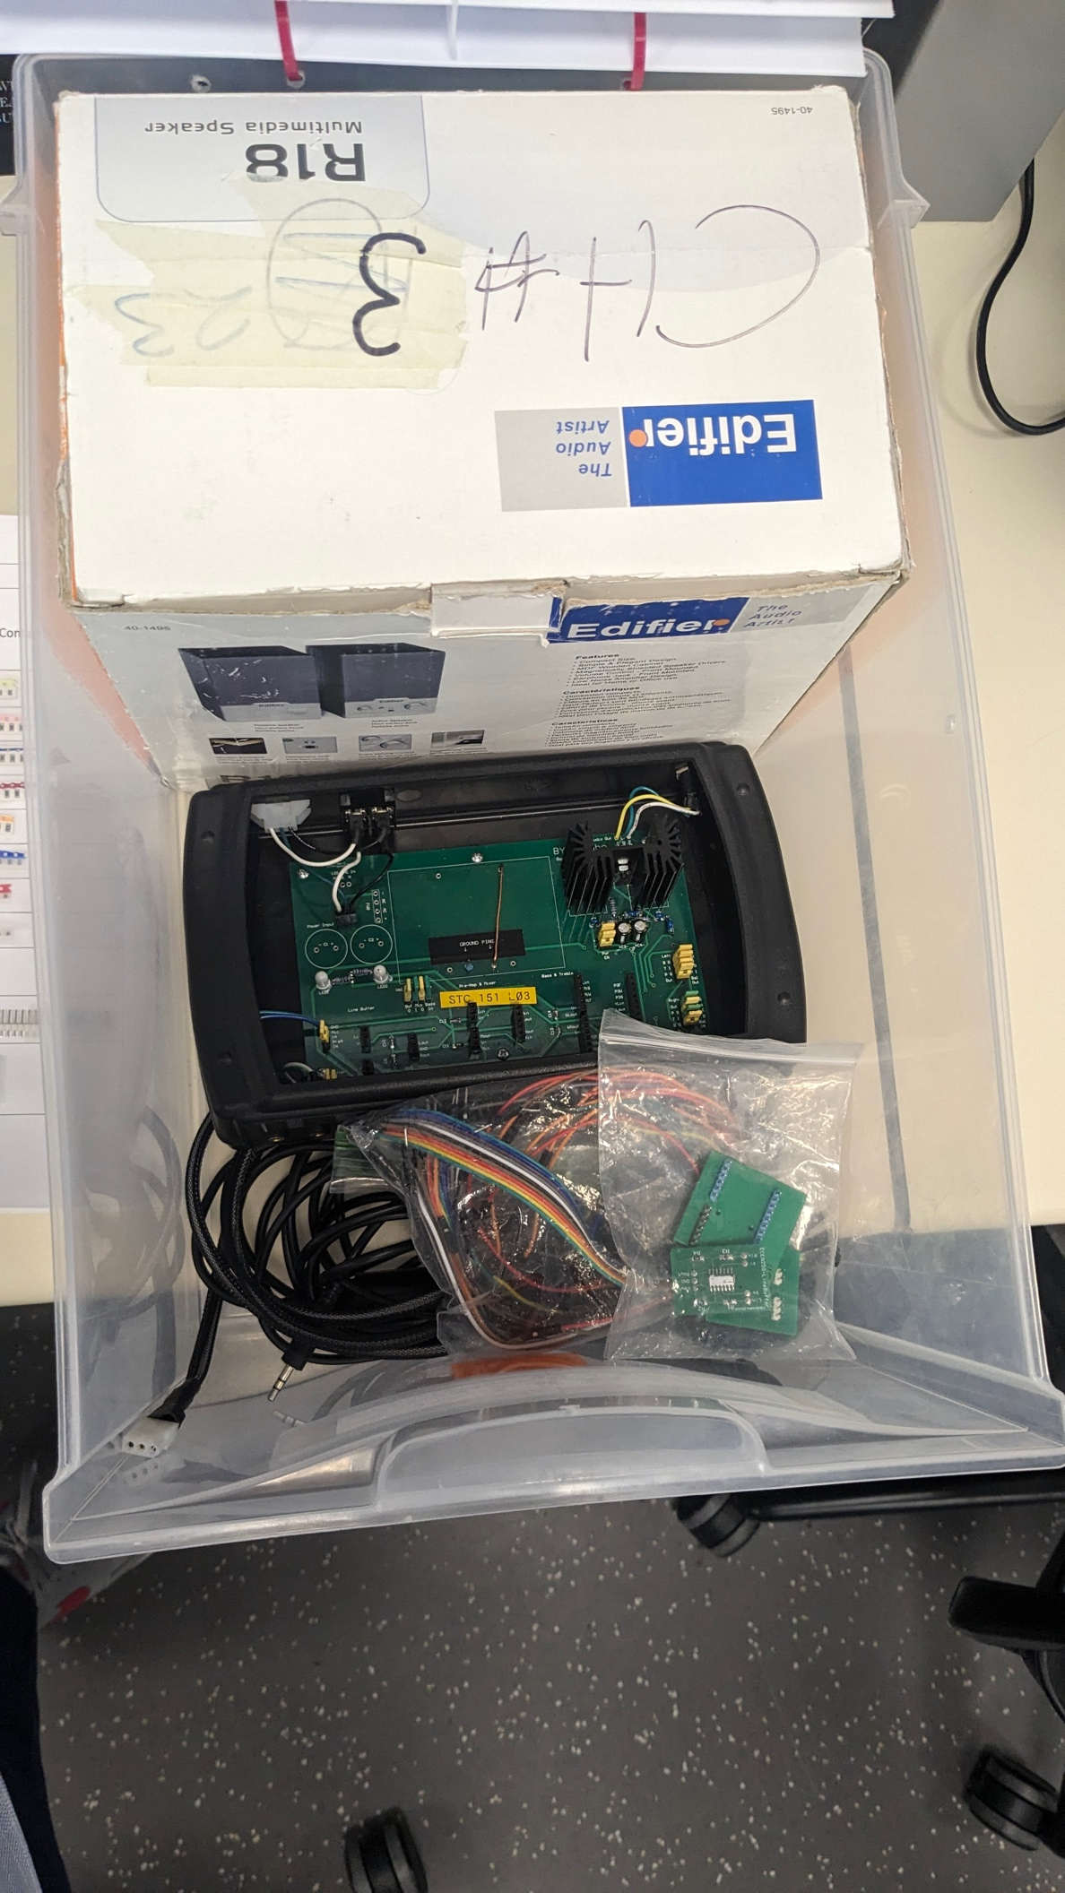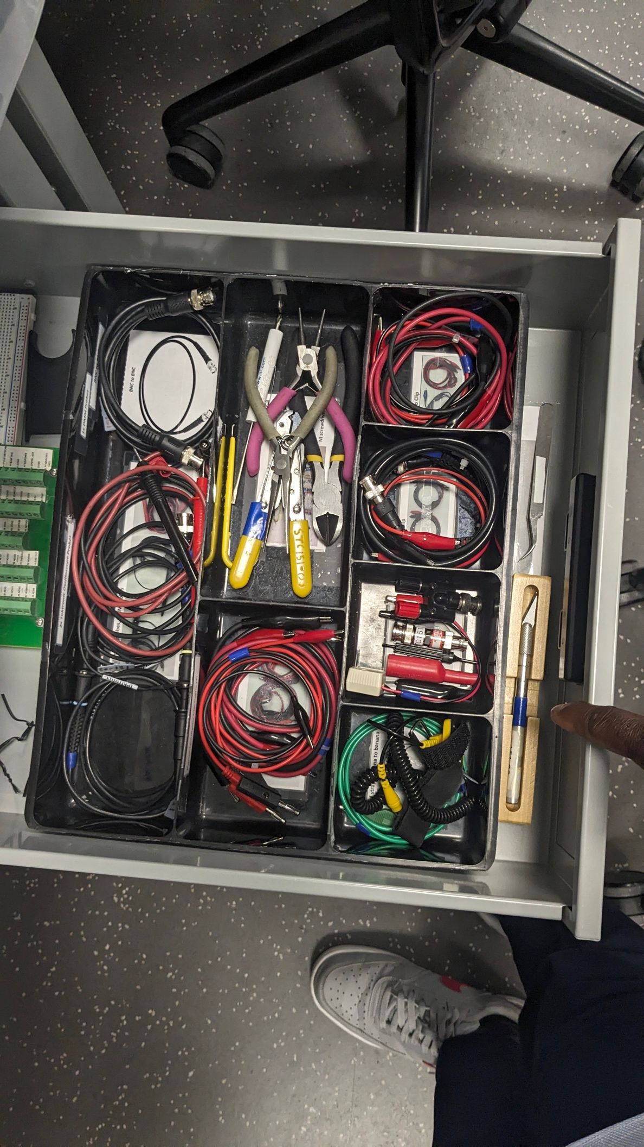

**Objectives**

Table 1 – Frequency Response

|  |  |  |  |  |
| --- | --- | --- | --- | --- |
| $V_{in}=2V_{pp}$**from Function Generator** | **Frequency** | $$V_{in\left(pp\right)}$$ | $$V_{out\left(pp\right)}$$ | **Gain $\left(A=\frac{V_{out\left(pp\right)}}{V_{in\left(pp\right)}}\right)$** |
| **Right**  **Channel** | **20 Hz** | 3.84 | 5.68 | 1.479 |
| **Right**  **Channel** | **20 kHz** | 3.92 | 5.84 | 1.48 |
| **Left**  **Channel** | **20 Hz** | 4 | 5.7 | 1.425 |
| **Left**  **Channel** | **20 kHz** | 4 | 5.8 | 1.45 |

|  |  |  |  |  |
| --- | --- | --- | --- | --- |
| **Amplifier** | **Frequency (Hz)** |  |  | **||** |
| **Pre-Amp** | $$20$$ | 48mV | 9.28v | 45.73dB |
| $$20k$$ | 47.2mV | 9.44v | 46.03dB |
| **Mixer Left Channel** | 20 | 5.36V | 11.2V | 6.41dB |
| $$20k$$ | 5.6 | 11.4 | 6.19dB |
| **Mixer Right Channel** | 20 | 5.36 | 11.2 | 6.41dB |
| $$20k$$ | 5.6 | 11.4 | 6.19dB |

Table 2: Pre-Amp and Mixer Frequency Response

Table 3 Treble and Bass Frequency Response Measurements.

|  |  |  |  |  |  |  |  |  |
| --- | --- | --- | --- | --- | --- | --- | --- | --- |
|  | **Channel** | $$f(Hz)$$ | **Treble** | | | **Bass** | | |
|  |  |  |  |  |  |
|  | **Left** | $$20Hz$$ | **2.16** | **2.16** | **0dB** | **2.16V** | **720mV** | **-9.54dB** |
| $$20kHz$$ | **2.16** | **9.20** | **12.58dB** | **2.28** | **2.24** | **-0.17dB** |
| **Right** | $$20Hz$$ | **2.20** | **2.20** | **0dB** | **2.20** | **1.20** | **-5.23dB** |
| $$20kHz$$ | **2.32** | **592mV** | **-11.88dB** | **2.32** | **2.32** | **0dB** |
| $$α=1$$ | **Left** | $$20Hz$$ | **2.16** | **2.16** | **0dB** | **2.16V** | **7.36V** | **10.66dB** |
| $$20kHz$$ | **2.28** | **1.40** | **-4.23dB** | **2.28** | **2.28** | **0dB** |
| **Right** | $$20Hz$$ | **2.20** | **2.20** | **0dB** | **2.20** | **7.60** | **10.77dB** |
| $$20kHz$$ | **2.12** | **9.2** | **12.75dB** | **2.32** | **2.32** | **0dB** |

Deviation Equation $$Deviation \left(dB\right)=20∙\log_{10}\left(\frac{V_{out\left(max\right)}}{V_{out\left(min\right)}}\right)$$

**Conclusion**

In this lab, we aimed to measure the performance of various PCB components, including the Line Buffer, Microphone Preamp, Mixer, and Treble and Bass circuits. The primary goal was to verify that the design specifications were met by comparing the physical measurements to the expected values.

The lab demonstrated the importance of testing and verifying is important in ensuring that electronic circuit designs meet their specifications. Each component's performance was measured and analyzed, with results indicating that the design specifications were generally met. Where deviations occurred, potential causes were identified and addressed.

By completing this lab, valuable hands-on experience was gained in using oscilloscopes, function generators, and other test equipment, as well as in interpreting and documenting measurement data.

# Verify Complete System Functionality {Buffer PCB, Mic. Preamp and Mixer PCB, and Treble & Bass PCB}

* Can you hear low frequencies being attenuated or boosted when the bass knob is turned fully counterclockwise or fully clockwise? YES
* Can you hear high frequencies being attenuated or boosted when the treble knob is turned fully counterclockwise or fully clockwise? YEs
* Does the microphone volume knob control the volume of the microphone coming out of the speakers? YEs
* Does the microphone come out of both the left and right speakers? YES
* Does the audio volume knob control the volume of the audio coming out the speakers?Yes
* Does the audio signal come out of both the left and right speakers?YES
* Do the microphone and the audio signals mix and come out of both the left and right speakers?YEs
* Does the balance knob change the percentage of sound coming out of the left and right speakers? YES

## Verify Buffer PCB and Preamp & Mixer PCB Functionality

* Does the microphone volume knob control the volume of the microphone coming out of the speakers? Yes
* Does the microphone come out of both the left and right speakers?Yes
* Does the audio volume knob control the volume of the audio coming out the speakers? YEs
* Does the audio signal come out of both the left and right speakers? Yes
* Do the microphone and the audio signals mix and come out of both the left and right speakers? YEs
* Does the balance knob change the percentage of sound coming out of the left and right speakers? YEs